**1 KINGS 11-12**

**Solomon Turns from the Lord**

**11 Now King Solomon loved many foreign women, along with the daughter of Pharaoh: Moabite, Ammonite, Edomite, Sidonian, and Hittite women, 2from the nations concerning which the Lord had said to the people of Israel, “You shall not enter into marriage with them, neither shall they with you, for surely they will turn away your heart after their gods.” Solomon clung to these in love. 3He had 700 wives, who were princesses, and 300 concubines. And his wives turned away his heart. 4For when Solomon was old his wives turned away his heart after other gods, and his heart was not wholly true to the Lord his God, as was the heart of David his father. 5For Solomon went after Ashtoreth the goddess of the Sidonians, and after Milcom the abomination of the Ammonites. 6So Solomon did what was evil in the sight of the Lord and did not wholly follow the Lord, as David his father had done. 7Then Solomon built a high place for Chemosh the abomination of Moab, and for Molech the abomination of the Ammonites, on the mountain east of Jerusalem. 8And so he did for all his foreign wives, who made offerings and sacrificed to their gods.**

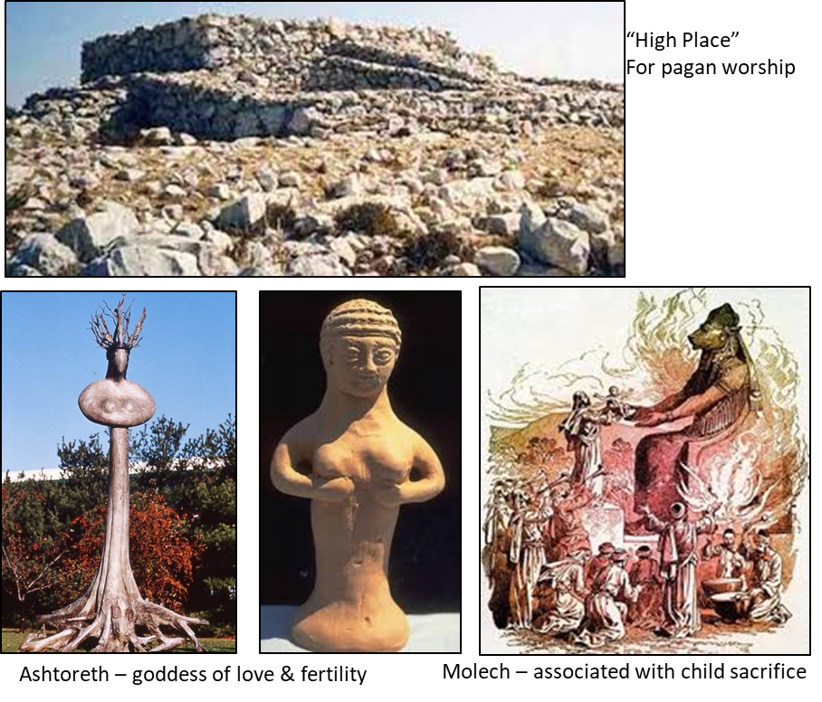

**The Lord Raises Adversaries**

**9And the Lord was angry with Solomon, because his heart had turned away from the Lord, the God of Israel, who had appeared to him twice 10and had commanded him concerning this thing, that he should not go after other gods. But he did not keep what the Lord commanded. 11Therefore the Lord said to Solomon, “Since this has been your practice and you have not kept my covenant and my statutes that I have commanded you, I will surely tear the kingdom from you and will give it to your servant. 12Yet for the sake of David your father I will not do it in your days, but I will tear it out of the hand of your son. 13However, I will not tear away all the kingdom, but I will give one tribe to your son, for the sake of David my servant and for the sake of Jerusalem that I have chosen.”**

**Violations of God’s law:**

|  |  |
| --- | --- |
| **Deut 7** | **Regarding inter-marriage with pagan nations**  **3**You shall not intermarry with them, giving your daughters to their sons or taking their daughters for your sons, **4**for they would turn away your sons from following me, to serve other gods. |
| **Exodus 34** | **Regarding the worship centers of pagan gods**  **13**You shall tear down their altars and break their pillars and cut down their Asherim **14**(for you shall worship no other god, for the Lord, whose name is Jealous, is a jealous God)… |
| **Deut 17** | **Regarding the future Kings of Israel**  **17**And he shall not acquire many wives for himself, lest his heart turn away… |
| **1 Kings 9** | **God’s warning to Solomon**  **6**But if you turn aside from following me, you or your children, and do not keep my commandments and my statutes that I have set before you, but go and serve other gods and worship them, **7**then I will cut off Israel from the land that I have given them… |

**Compare:**

|  |  |
| --- | --- |
| **1 Kings 3:3** | **3Solomon loved the Lord, walking in the statutes of David his father…** |
| **1 Kings 11:4** | **4For when Solomon was old his wives turned away his heart after other gods…** |

|  |  |
| --- | --- |
| **1 Kings 3:3** | **3Solomon loved the Lord, walking in the statutes of David his father, only he sacrificed and made offerings at the high places.** |
| **1 Kings 11:4** | **4For when Solomon was old his wives turned away his heart after other gods…** |

**Jonah 2:8** (NIV)

**“Those who cling to worthless idols, forfeit the grace that could be theirs”**

**Proverbs 4:23** (NIV)

**Above all else, guard your heart,  
    for everything you do flows from it.**

**I Kings 11 (Con’t)**

**26Jeroboam the son of Nebat, an Ephraimite of Zeredah, a servant of Solomon, whose mother's name was Zeruah, a widow, also lifted up his hand against the king. 27And this was the reason why he lifted up his hand against the king. Solomon built the Millo, and closed up the breach of the city of David his father. 28The man Jeroboam was very able, and when Solomon saw that the young man was industrious he gave him charge over all the forced labor of the house of Joseph. 29And at that time, when Jeroboam went out of Jerusalem, the prophet Ahijah the Shilonite found him on the road. Now Ahijah had dressed himself in a new garment, and the two of them were alone in the open country. 30Then Ahijah laid hold of the new garment that was on him, and tore it into twelve pieces. 31And he said to Jeroboam, “Take for yourself ten pieces, for thus says the Lord, the God of Israel, ‘Behold, I am about to tear the kingdom from the hand of Solomon and will give you ten tribes 32(but he shall have one tribe, for the sake of my servant David and for the sake of Jerusalem, the city that I have chosen out of all the tribes of Israel), 33because they have forsaken me and worshiped Ashtoreth the goddess of the Sidonians, Chemosh the god of Moab, and Milcom the god of the Ammonites, and they have not walked in my ways, doing what is right in my sight and keeping my statutes and my rules, as David his father did. 34Nevertheless, I will not take the whole kingdom out of his hand, but I will make him ruler all the days of his life, for the sake of David my servant whom I chose, who kept my commandments and my statutes. 35But I will take the kingdom out of his son's hand and will give it to you, ten tribes. 36Yet to his son I will give one tribe, that David my servant may always have a lamp before me in Jerusalem, the city where I have chosen to put my name. 37And I will take you, and you shall reign over all that your soul desires, and you shall be king over Israel. 38And if you will listen to all that I command you, and will walk in my ways, and do what is right in my eyes by keeping my statutes and my commandments, as David my servant did, I will be with you and will build you a sure house, as I built for David, and I will give Israel to you. 39And I will afflict the offspring of David because of this, but not forever.’” 40Solomon sought therefore to kill Jeroboam. But Jeroboam arose and fled into Egypt, to Shishak king of Egypt, and was in Egypt until the death of Solomon.**

**41Now the rest of the acts of Solomon, and all that he did, and his wisdom, are they not written in the Book of the Acts of Solomon? 42And the time that Solomon reigned in Jerusalem over all Israel was forty years. 43And Solomon slept with his fathers and was buried in the city of David his father. And Rehoboam his son reigned in his place.**



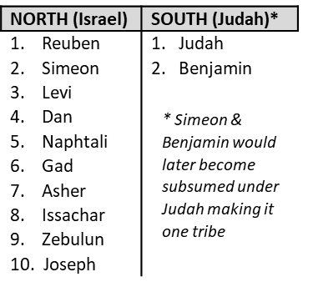

**Principle:** God will temporarily tear down his own kingdom/people to accomplish His work and for their benefit and His glory.

We wonder, “Can God PRESERVE what He is DESTROYING? *Yes!*

### Rehoboam's Folly

**12 Rehoboam went to Shechem, for all Israel had come to Shechem to make him king.**

**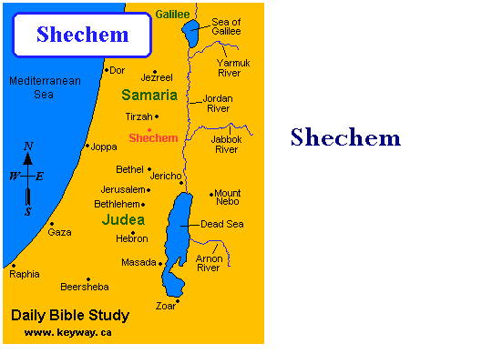 2And as soon as Jeroboam the son of Nebat heard of it (for he was still in Egypt, where he had fled from King Solomon), then Jeroboam returned from Egypt. 3And they sent and called him, and Jeroboam and all the assembly of Israel came and said to Rehoboam, 4“Your father made our yoke heavy. Now therefore lighten the hard service of your father and his heavy yoke on us, and we will serve you.” 5He said to** **them, “Go away for three days, then come again to me.” So the people went away.**

**6Then King Rehoboam took counsel with the old men, who had stood before Solomon his father while he was yet alive, saying, “How do you advise me to answer this people?” 7And they said to him, “If you will be a servant to this people today and serve them, and speak good words to them when you answer them, then they will be your servants forever.” 8But he abandoned the counsel that the old men gave him and took counsel with the young men who had grown up with him and stood before him. 9And he said to them, “What do you advise that we answer this people who have said to me, ‘Lighten the yoke that your father put on us’?” 10And the young men who had grown up with him said to him, “Thus shall you speak to this people who said to you, ‘Your father made our yoke heavy, but you lighten it for us,’ thus shall you say to them, ‘My little finger is thicker than my father's thighs. 11And now, whereas my father laid on you a heavy yoke, I will add to your yoke. My father disciplined you with whips, but I will discipline you with scorpions.’”**

**12So Jeroboam and all the people came to Rehoboam the third day, as the king said, “Come to me again the third day.” 13And the king answered the people harshly, and forsaking the counsel that the old men had given him, 14he spoke to them according to the counsel of the young men, saying, “My father made your yoke heavy, but I will add to your yoke. My father disciplined you with whips, but I will discipline you with scorpions.” 15So the king did not listen to the people, for it was a turn of affairs brought about by the Lord that he might fulfill his word, which the Lord spoke by Ahijah the Shilonite to Jeroboam the son of Nebat.**

### The Kingdom Divided

**16And when all Israel saw that the king did not listen to them, the people answered the king, “What portion do we have in David? We have no inheritance in the son of Jesse. To your tents, O Israel! Look now to your own house, David.” So Israel went to their tents. 17But Rehoboam reigned over the people of Israel who lived in the cities of Judah. 18Then King Rehoboam sent Adoram, who was taskmaster over the forced labor, and all Israel stoned him to death with stones. And King Rehoboam hurried to mount his chariot to flee to Jerusalem. 19So Israel has been in rebellion against the house of David to this day. 20And when all Israel heard that Jeroboam had returned, they sent and called him to the assembly and made him king over all Israel. There was none that followed the house of David but the tribe of Judah only.**

**21When Rehoboam came to Jerusalem, he assembled all the house of Judah and the tribe of Benjamin, 180,000 chosen warriors, to fight against the house of Israel, to restore the kingdom to Rehoboam the son of Solomon. 22But the word of God came to Shemaiah the man of God: 23“Say to Rehoboam the son of Solomon, king of Judah, and to all the house of Judah and Benjamin, and to the rest of the people, 24‘Thus says the Lord, You shall not go up or fight against your relatives the people of Israel. Every man return to his home, for this thing is from me.’” So they listened to the word of the Lord and went home again, according to the word of the Lord.**